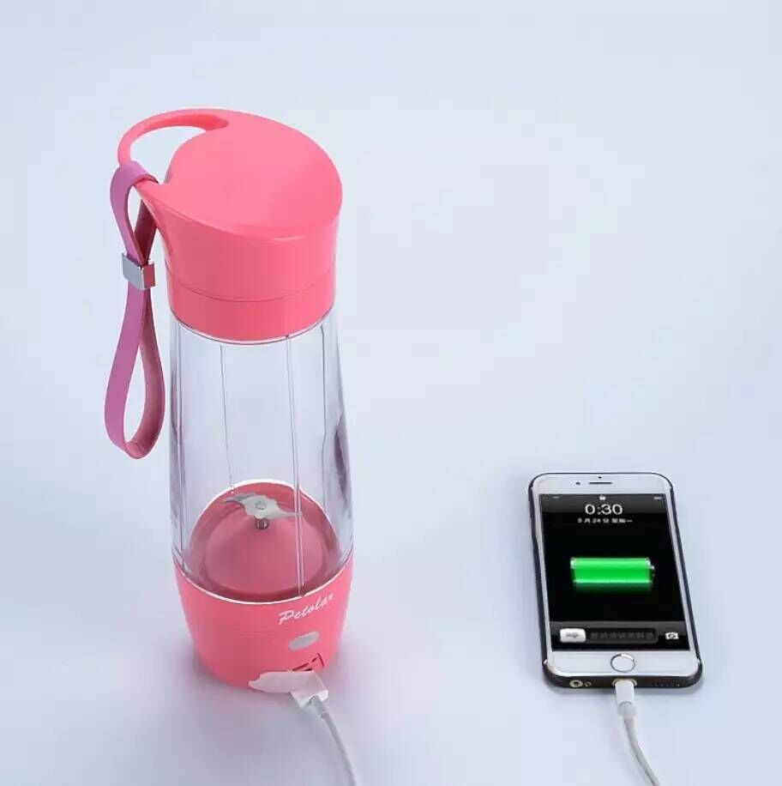

|  |
| --- |
| Feasibility Report |

|  |  |  |
| --- | --- | --- |
| Electric Water Bottle |  |  |
| Name:  Student ID: | Email:  Date: |  |

Table of contents

1. Executive Summary 3

2. Business Opportunity 4

2.1. Market Gap 4

2.1. Value Proposition 4

3. Micro Market 6

4. Macro Market 8

5. Micro Industry 9

6. Macro Industry 11

6.1. Business Model 11

6.2. Suppliers 12

7. Financial Analysis 13

7.1. Cash flow Analysis 13

8. Recommendation & Reflection 14

9. Appendices 15

9.1. PESTLE Analysis 15

9.2. Cash flows 15

10. References 17

# Executive Summary

Can you ever imagine yourself surrounded by technology in society? Can you consider yourself so quick in transforming the state of the water from cold to heat and vice versa in your hand? If you are looking for such a miracle, Congratulation, you have it now. Yeah, the “Electric Bottle”.

Indeed, lacking in society for the absence of technology creates a gap that causes the unhygienic water for health. There are bacteria is available in the local water which creates uncertainty to maintain healthy life significantly. In addition, specifically for the summer weather, the community is unable to seek cold water by managing the dignity of the healthy water. On the other hand, in winter people look for the pot to boil the water briefly.

Currently, the problems facing by society could be eliminated only one name comes in our mind is “Electric Bottle”. It helps to provide the customer which is easy to carry anywhere anytime no matter the weather you are in and it supports like a dispenser for the time of urgency. Everybody is busy in their daily routine, who wants to save their time which could be achieved by using this product. Moreover, it is less costly of £40 and provide the pure water that could maintain the prosperity of health-giving water.

Monitoring the actions, we do in our daily life with the time stamp of 6 – 7 hours. The usual capacity to drink the water could be 2 cups, might be 4 cups, but not more than 8 cups of water. Our product “Electric Bottle” can carry the water of utmost 8 cups which removes the headache of most people and gives them a chance to maintain their extent while doing their daily routine tasks.

# Business Opportunity

## Market Gap

The primary concern is for a living is not water but healthy water. Where people are unable to find it with the proper maintaining the quality of it. There are available bottles where one can maintain the hot water state in the pot and some of them are you can put the cold water and it assists to maintain the atmosphere inside the bottle.

There is a purifier in the market, from it you can make the water hot and cold or make it normal as well. But it is unable to carry anywhere which is not portable. There are bottles that can help to maintain the state inside the water but could not transform the water into heat and cold. There is not any machine that can drinking water can be cold or can be hot within 15 minutes of time on the current research of the market. Which is a wastage of the time that is crucial in terms of time? Other resources like the price of that machine is super high which is unable to buy this kind of expensive product.

Literally, “*Pure Water is the World's First and Foremost Medicine*” Slovakian Proverb. Pure water in this generation is very hard to find when people travel from one place to another. They are not portable or impotent to get while busy in their busy schedule. People are seeking for physical fitness, as pure water is the key to it.  While not getting pure water lead us to the doctor for treatment. It is necessary to take pre-measure in order to get rid of the disease that can hit us. Inherently, the higher authorities at the public place are unable to provide it which causes the spark of the deadly viruses in the community.

## 2.1. Value Proposition

Considering the current problems taken into account. It is the dominant time to give the idea that pop up in our mind is ***Electric Bottle***. It has significance effects in the lives who give value to a healthy choice of pure water.

Here are the points we contribute in the society for the betterment of digitize world.

Furnishing these services to the people in one variant makes them dedicated to this product fully. What’s more, to add, it is easy to carry anywhere with you whether at home, offices, gym, etc. You do not need to go to any dispenser if you keep this with you. Its service is very quick than traditional purifier. It gets almost 15minutes to make the cold water into heat and vice versa.

Time is money said by some anonymous. Through this product your time is in your hand, how it is possible, is it possible because you do not need to make your water hot on the boiling point or at the fridge. The water can be changed on the run easily. It is affordable for people who likes to have health-giving styles of life and it maintains the quality of life in a small pack.

There is not any worry to carry the bigger pot for this all functionality in one small place, it is easy carriable and it can be put in the hand or in the bag or a box. Having its size shorter makes it attractive and noticeable, in the current era people love to choose tiny a product which can be super smart to use and utilize its highest potential to it.

# Micro Market

Focusing on the market, it is important to seek for the specific groups who uses which amount of water and how we can hit the market by the product we provide to society. Taking into consideration the usual number of cups normal humans can consume are mentioned above in the pie diagram. There are specific groups who use 2-5 or more than 5 cups in the whole day.

Starting from the lowest consumer who takes the 2 cups in the whole day are 5%.

In addition, for the 3 cups of the consumer at even away from the usual limits of drinking water in a day which are up to 7%.

For looking at the 4 cups per day are much well to devour are falling in the category of 14%.

Seeking for the 5 cups in a day are much wider than all the categories of people who take almost 70% in society.

The rest is more than 5 cups per day is leaves with 4% of the consumer of water.

Depicting from this picture helps to understand that most of the people who take 5 cups in a day. Where our ***Electric bottle***comes in the market and take up to 5 cups of water.

There are some categories where people want to pay according to the respective pounds for the electric bottle which speaks their need and want against this product.

Where the majority lies in the category of 15-20 the pound is up to 50% and they are the largest category among all. Where there are 20-30 pounds people need to pay up to 25% rest are the 30-40 pound is 18 % and rest are for above 40 pounds.

What we value the most in our product is worth considering and give some time to think for its full potential where 90% we provide the functionality to it and 6% to its visibility to the customer and rest of the 4% are for its color.

We divide to make this electric bottle in some respective categories which are necessary for the customer to have. It is mandatory for all of us to at least have these categories to get their potential and worth of using it. There might be some other areas which could meet and boost this product. However, this is the best we can come to what the customer really wants, and we know the customer is the final arbiter.

# Macro Market

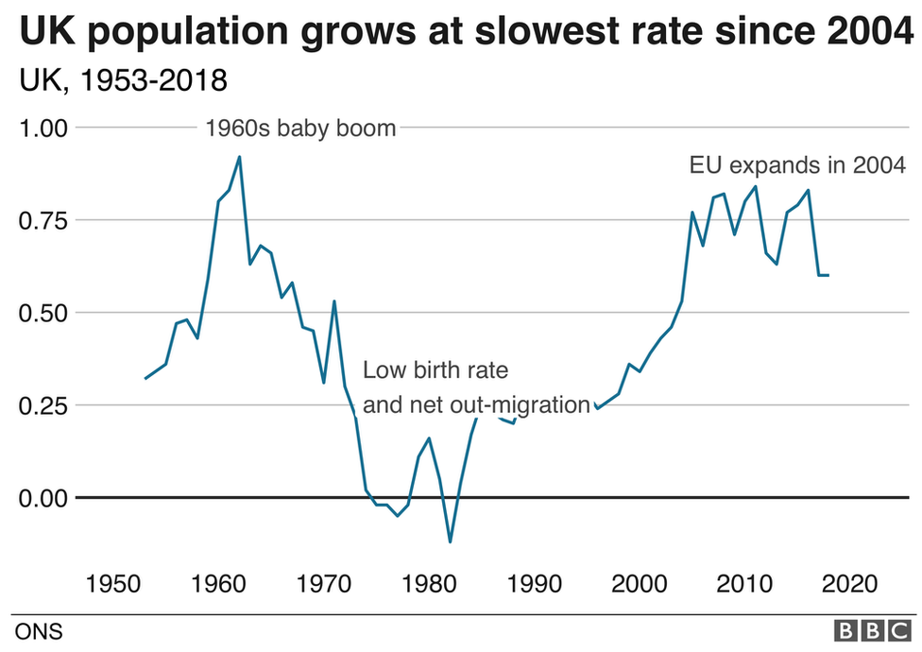This below graph shows the UK population growth rate from 1953 to 2018. this shows that in the 1960s the UK’s population has increased and there is a baby boom in the population. While after the 1960s trend shows there is a decrease in population till the 1980’s due to the low birth rate and net out-migration. After 1980 till today the UK population is increasing and there are better opportunities and gap for us to enter the market.

Growth rate shows the potential is to enter in this time for this product to present among the market while maintaining the its potential to its peak.

When we look deeper into the market, we need to look harder the customer's size and its relevant need with respect to its percentage.

Pursuing this, 7 in 10 people consumed relevant product, mostly aged between 10 to 80 total population in that age group is 16.87 million people. Moreover, 70% of 16.87 million = Number of customers and 11.809 million potential customers.

Further, Our Market is non-existence at the moment, so the people we aim at are people in a healthy lifestyle. We provide them with portable heating and cooling bottle to make a beverage on the way.

# Micro Industry

How to cope with the difficult situation when we start the business in the first place to open. There must be some competitors we need to take care of. There are two types of competitors od in this “Electric Bottle” idea. Direct and indirect which are below: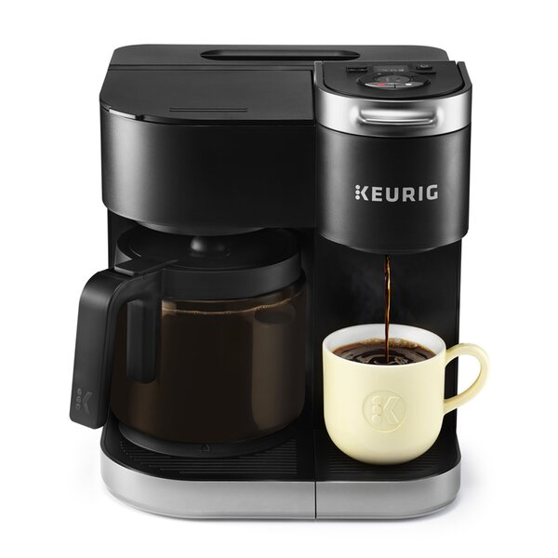

**Direct competitors**

* Water dispensers
* Water bottle, like Nestle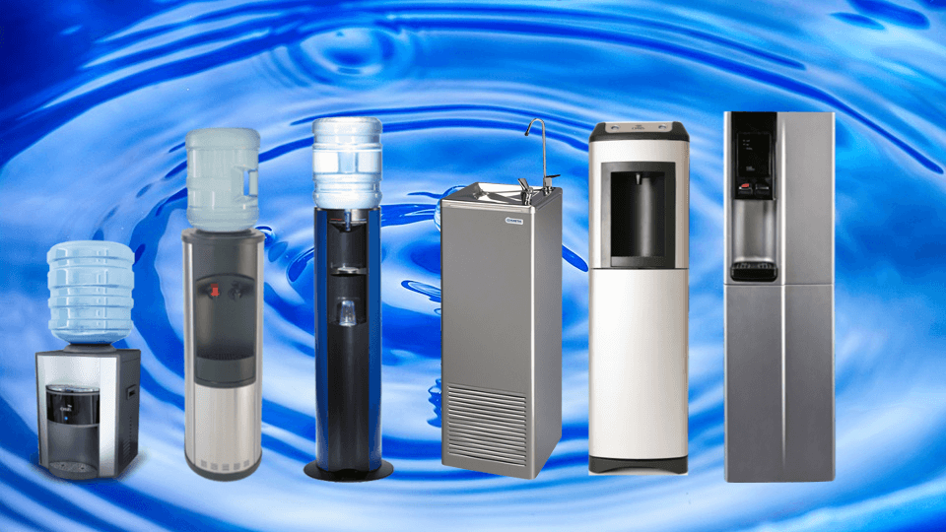

**Indirect competitors**

* Coffee maker
* Tea maker

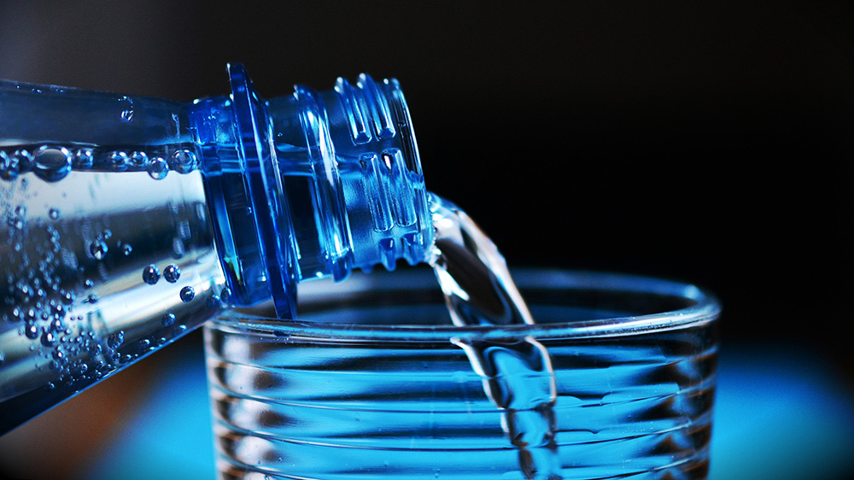

# Macro Industry

## Business Model

|  |  |  |  |  |
| --- | --- | --- | --- | --- |
| Key Activities   * Drinking Water bottles * 20-liter bottle refill * Water filter * Water purifier machine * Water cool and heat mechanism in the bottle | Key Resources   * The main factory * Employees * Refilling centers * Capital | Value Proposition   * Customers first * Ease of access everywhere of cold and hot water * Less costly * Pure water | Customer relationship   * Suggestions and recommendations will be welcomed * Complaint system would be efficient and effective * Surveys will be conduct for feedback about company’s performance and quality | Customer segments   * Household customers * Business firms * Shops * Factories * School colleges * Other institutions |
| **Key Partnership**   * Government licensing * Suppliers for machine * Technical assistance from co-ventures |
| **Cost structure**   * Perpetual inventory system will be used * Cost of production report will be analyzed on monthly basis * Control flaws nd fill gaps mistakes | | | **Channels**   * Outlets * Franchises * Home delivery services |
| **Revenue streams**   * Cost plus pricing strategy would be used * Average revenue forms all products nd services will be = cost plus 60% profit * Company has to survive until breakeven point of maximum period of almost 6 months | | | | |

## Suppliers

Suppliers of these ideas are who could provide the machine through which we can make the electric bottle workable. In addition, their equipment of functionality from where water can be heated or can be cold, both significant parts must be embedded together in a cover to make it solo. In simple, our product provides the functionality of making the hot water and cold too, their proper machinery must be borrowed from some company in order to make our product alive.

Material for the cover, whether the bottle is made up of plastic, fibber, lamination, and steel. Moreover, Lamination, plastic, and still would be necessary for the different parts of the bottle. Respective sensors would be necessary to know the temperature of the water inside the bottle.

Summing up, the supplier could be a sensor company, plastic, lamination, steel company, and sensor companies as well in order to assemble them and most important the labour from some assemble company as well.

# Financial Analysis

## Cash flow Analysis

As for finance, the part must be mandatory to mentioned here. Moreover, the total investment is 200,000 & the selling of the product is 40pounds. The cost price must be less than the selling price which is 38 pounds. There is one source of investment Lloyd Bank 80,000 pounds. Where the investment source 3 is from my 2 partners 60,000 pounds each. At the last, the payback period would be the utmost 1 year.

|  |  |
| --- | --- |
|  |  |

There are two parts in the cash flow statements one of income and the other is expenditure. Income sources are Operating balance, Director’s loan, Bank Loan and sales. Total income through the year is 1975000.

On the other hand, Expenditure contains various things. For instance, Wages and salaries, Enlistment of business, Licenses, Advertising cost, Business adviser cost, Software cost, Office rent, Stationary cost, Telephone and utility, operational expenses, Furniture and fixture, Propelling of the website, miscellaneous expense. Total expense is about throughout the year 2342740. Where first 11 month goes in negative and the other one month has positive value in the cash flow statement.

# Recommendation & Reflection

Through the journey of this idea, it looks feasible to run but there must be some other measure which must take place. Although, research has taken place to see the sustainability of this idea but still require some experience contribution for further clarifications.

One who is trying to run the business he/ she has to make sure the idea will run how much year and which factors it has been fulfill while it is in the run. It helps to make sure that it can run smoothly, or it will create some trouble when it walks in the field when we launch for the use of the community.

# Appendices

## PESTLE Analysis

Evaluation of the PESTEL is one of the many macro analysis strategies to determine the business idea. It helps to evaluate the services, product etc. It assists to analyse the all environmental factors which leads to make the decision strong of all the company those follows.

**Political factors:**

The higher authorities with the experience they had within the operation of manufacturing Electric Bottles under the umbrella of legislation. There is potential penalty by the federal government for the manufacturing if they are lacking to get the proper standards. It genuinely affects the business, when the alteration in any regulations by the government when changes in the text, newly update tax rate, making the finance area, local and global restriction for the electic Bottles.

**Economic factors:**

Economy is one of the important factors, which decide the successfulness of the business or its failure. It depends on the industry grows with its successfulness or failure. As the time goes the venture and setting up the venture becomes the really very difficult task. If a company Electric Bottle have negative growth and doe not have cash and rich themselves. Trough the current negative growth is the one borrowing interest is also low. Where Electric Bottle can borrow some money to research on technology.

**Social factors:**

Currently, each and everyone wants to stay healthy. There are some damaging effects of using unhygienic water. More and more people looking for healthy life means healthy water. The respective process has contributed to this idea to buy Electric Bottle which is healthy and contribute to the society and make it more social in terms of non-alcoholic healthy water.

**Technological factors:**

Trend is changing day by day with the contribution of product that is highly health for most of the people.

The state-of-the-art technology is diverging to the modern age of Electric Bottle. It contributes the tap bottle healthy water in order to maintain the potential of its existence. The synergy achieved through the right mix of advertising, marketing and promotional programs can not be ignored. Where this product is itself the advancement of the bottle company.

**Legal factors:**

The minor changes in the law of chemicals allowed in the Electric bottle. Impression from the legislation is higher enough to shut the organization which are not legally bound to it. There are different guideline or compliance why gives the warning of three years if they are not able to prove their legal legislation.

## Cash flows

# References

* Harmon, R., Demirkan, H., Hefley, B. and Auseklis, N., 2009, January. Pricing strategies for information technology services: A value-based approach. In *2009 42nd Hawaii International Conference on System Sciences* (pp. 1-10). IEEE.
* KD markets insights, (2020). Electric water bottle market insights, trends, opportunity, and Forecast. [online]. Available from: <https://www.kdmarketinsights.com/product/260/2018-global-electric-water-bottle-industry-report> [Accessed 25 March 2020].
* Inms, and Tbm, (2020). Growth rate of UK graph. [online]. Available from: <https://www.google.com/search?q=UK+Population+growth+rate+graph&rlz=1C1AVFC_enPK859PK859&source=lnms&tbm=isch&sa=X&ved=2ahUKEwiciMni9L3oAhVKxoUKHdyxBrUQ_AUoAXoECBkQAw&biw=1366&bih=657#imgrc=LI39gIaG3d-LVM> [Accessed 27 March 2020].
* Google locations, (2020). Harrods London location graph. [online]. Available from: <https://www.google.com/maps/place/Harrods/@51.4994055,-0.1632344,15z/data=!4m5!3m4!1s0x0:0x15ee630d4b4e0d42!8m2!3d51.4994055!4d-0.1632344> [Accessed 27 March 2020].
* Kenton W., (2019). Promotions. [online]. Available at: <https://www.investopedia.com/terms/p/promotion.asp> [Accessed 29 March 2020].
* Tutor2u, (2020). Cash flow forecasting for a startup. [online]. Available from: <https://www.tutor2u.net/business/reference/cash-flow-forecasting-for-a-startup> [Accessed 28 March 2020].
* BMI design tools, (2020). Business Model Canvas. [online]. Available at: <https://www.businessmodelsinc.com/about-bmi/tools/business-model-canvas/> [Accessed 28 March 2020].
* Howes, L., (2013). 4 ways to pull ahead of your competitors in business. [online]. Available from: <https://www.entrepreneur.com/article/225914> [Accessed 29 March 2020].
* Jaffries, I., (2019). Value proposition: Bottled Water. [online]. Available from: <https://isaacjeffries.com/blog/2017/7/12/value-propositions-bottled-water> [Accessed 29 March 2020].